Ethiopia Testimony

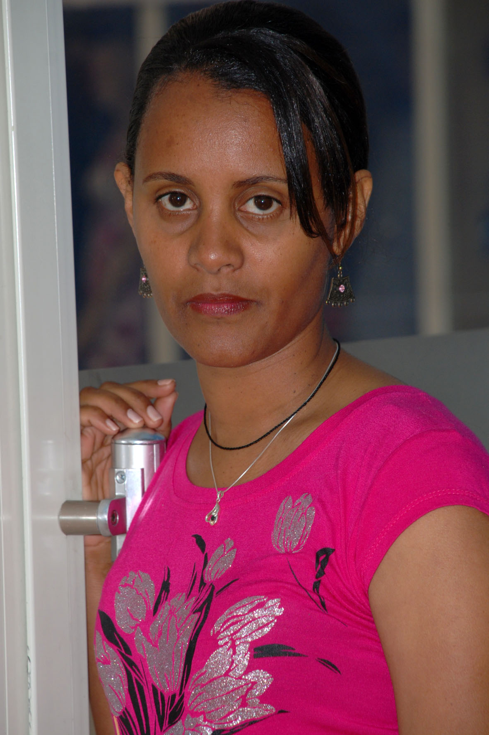 | Mahlet Tadesse  choosyt@gmail

“I remember that before 17 years ago my heart was very seek in that time.
I was kid after so many problems I found the surgeon doctor in USA
university of masseuses medical center hospital DR.tomas pezzella he
accept me my question and then the open surgery is successfully done.
The martial valve is replaced. After the surgery my heart is working
properly my breathing is finally perfect I still am free from illness
taking medicine daily in the night every month I follow-up my heart in
the cardiac hospital everything is good am working, running, dancing,
playing I don’t have any problems after the surgery am happy girl this
is my life experience.”

