Dedication of ICHF Project to Establish a Model 5 year Cardiothoracic Surgery Residency Program in Vietnam

Background
The U.S. Census Bureau (2004) reports there are 8.2 million "Vietnam Era Veterans". Of these 2.59 million are reported to have served "in country".
United States Armed Forces Casualties as of 6 June 2012:
58,282 KIA or non-combat deaths (including the missing & deaths in captivity)
303,644 WIA (including 153,303 who required hospitalization and 150,341 who didn't)
1,664 MIA (originally 2,646)
725-779 POW (660 freed (28 escaped), 65-119 died in captivity)
http://en.wikipedia.org/wiki/Vietnam_War_casualties

A 6 month project (July 14, 2012- January 4, 2013) to revise and modify the HCM city Medical University Cardiothoracic surgery residency program, as well as to advise and consult on the preoperative, operative, and postoperative care of cardiothoracic patients at Cho Ray Hospital in Ho Chi Minh City, Vietnam is dedicated to the US military and civilian service personnel who served in the Vietnam or American war from 1959-1975
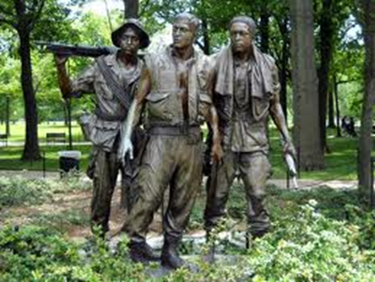  Vietnam Memorial  Washington DC, USA | 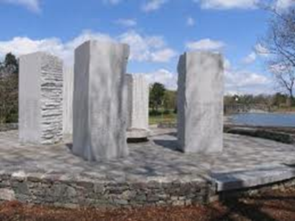  Vietnam Memorial  Worcester, MA, USA

